Experiment No. 2
Signal Operations and Transformations

2.2. To perform time shifting and time reversal of continuous-time and discrete-time signals and analyze the resulting transformations
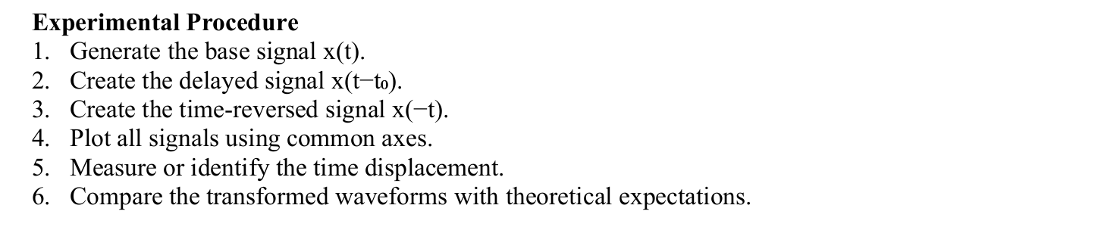
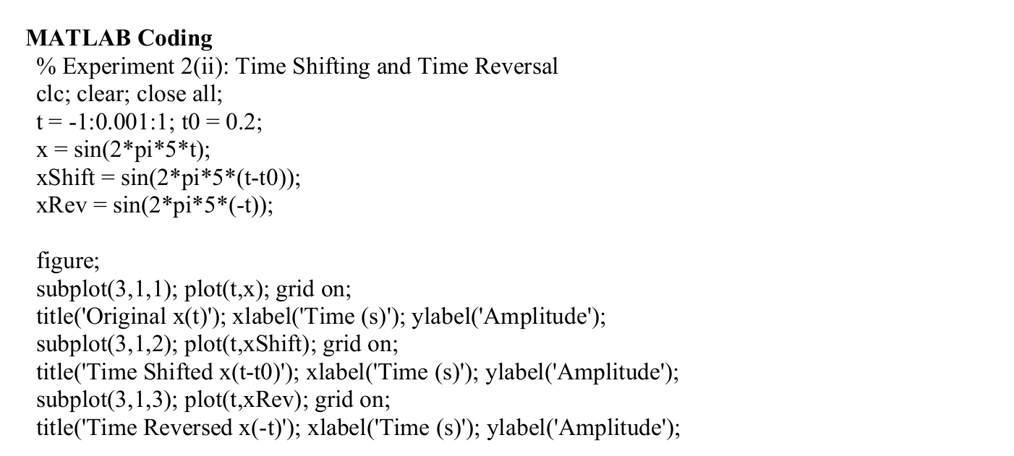
Output:
